Exploration of Efficient and Economical Catalysts for Alkaline Water Electrolysis

Lead Author: Woo Hyeon Kim, Hyeong Seong Shim, Min Woo Kim, Jae Young Lee, Jun Ho Choi,

Seo Jin Hwang, Won Woo Choi, Seo Jin Ryu

Co-Author: Chang Hyeon Moon, Hyun Seo Park, Joo Ha Jang, Ha Neul Kang, Yang Hyun Lee, Ha Jun Ko, Gyeong Min Ko

Jeonnam Science High School

Supporting Information Placeholder (Highly Recommended)

ABSTRACT: Green hydrogen has significant potential as a sustainable energy source, so finding efficient production method is critical. Conventional precious metal catalysts show high efficiency, but their high cost and limited available hinder their practical large-scale application. The aim of this study is to explore cost-effective and efficient non-noble metal catalysts for alkaline water electrolysis (AWE) in green hydrogen production.

Introduction

Since the Industrial Revolution, the indiscriminate use of fossil fuels and the rapid increase in energy consumption have sharply raised the atmospheric concentration of greenhouse gases, primarily represented by carbon dioxide (CO2). According to the Intergovernmental Panel on Climate Change (IPCC), as of 2023, the concentration of these gases has increased by 74% compared to 1990 levels, with CO2 emissions from fossil fuels and industrial activities constituting the largest share. To mitigate the accelerating problem of global warming, the development of renewable energy sources such as solar, wind, hydrogen energy, and fuel cells is underway. In particular, there is growing interest in hydrogen as an environmentally friendly energy carrier that can be stored, transported, and utilized.

Hydrogen is not only a clean energy resource but also serves as an energy carrier for storing renewable energy, and it has the potential to be quickly integrated into existing energy and transportation systems. Furthermore, as a non-toxic and lightweight gas, hydrogen disperses quickly into the air if leaked, ensuring safety and making it a highly attractive alternative to fossil fuels.

Hydrogen energy can be produced using various processes involving fossil fuels, biomass, and water through reforming, pyrolysis, electrolysis, and photolysis. Depending on the production method, hydrogen is categorized into several types, with the three most representative being gray, blue, and green hydrogen. Gray hydrogen is produced from fossil fuels, emitting a significant amount of CO2 as a byproduct. Blue hydrogen utilizes Carbon Capture, Utilization, and Storage (CCUS) technology to remove carbon monoxide and CO2 generated during the production of gray hydrogen. While gray and blue hydrogen are cost-effective, can be supplied in large quantities, and are produced in various countries, they have environmental pollution issues and lower reactivity.

Green hydrogen, on the other hand, is produced by electrolyzing water using renewable energy sources such as solar and wind power. Unlike the previous two types, green hydrogen can be produced in a highly pure form (99.999%) without carbon byproducts, making it the most environmentally friendly decarbonization energy resource. The International Renewable Energy Agency (IRENA) has emphasized the necessity of green hydrogen in limiting global temperature rise, highlighting its importance.

The electrochemical water splitting to produce green hydrogen can be classified into three main technologies: (i) high-temperature electrolysis, (ii) low-temperature electrolysis, and (iii) photolysis. High-temperature electrolysis involves splitting high-temperature steam (above 700°C) to produce hydrogen and typically employs solid oxide electrolyzer cells (SOECs). However, this method requires additional thermal energy and faces issues with material thermal stability at operating temperatures.

Low-temperature electrolysis operates at temperatures below 100°C, offering greater device stability and higher technological maturity, although challenges such as durability and efficiency degradation remain. Despite these issues, low-temperature electrolysis devices are gaining attention due to their ease of installation, operational stability, and direct integration with renewable energy sources like solar power. Representative low-temperature electrolysis devices include first-generation alkaline water electrolysis (AWE) and second-generation proton exchange membrane water electrolysis (PEMWE).

The classification of electrolysis generations typically hinges on the ability to directly integrate with renewable energy sources. Dense membrane systems like PEMWE and anion exchange membrane water electrolysis (AEMWE) have significant advantages in coupling with intermittent energy sources like solar power. During electrolysis, oxygen produced at the anode and hydrogen at the cathode can diffuse to the opposite electrodes, mixing the gases. While this mixing is negligible at high current densities due to the large volumes of gas produced, at low current densities, even a small amount of crossover can significantly impact the concentration of hydrogen in oxygen and vice versa, affecting safety.

Given the intermittent nature of solar power, the stability of electrolysis systems can be compromised. Therefore, when directly coupling solar systems with electrolysis for hydrogen production, second-generation electrolysis systems with dense membrane characteristics, which can fundamentally block gas crossover, are receiving increased attention.

In this study, the team tried to implement the second-generation water electrolysis system, which is most popular, but the research facilities and materials available in the high school were limited, so the team decided to experimentally implement the first-generation water electrolysis device, alkaline phosphorus water electrolysis.

|  |
| --- |
|  |

Materials and Methods

1. Dissolve 40g of NaOH used as electrolyte in distilled water to make a 1M aqueous solution of NaOH in a 1000mL volumetric flask.
2. Weigh out 0.005mol each of CaCl2, NiCl2, CuCl, Fe2SO4, Fe2(SO4)3, and FeCl2 to be used as catalysts.
3. Divide 1M NaOH aqueous solution into 100mL portions using a graduated cylinder into each beaker, add the prepared catalyst and mix.
4. Place each beaker on a stirrer and adjust the temperature to 75 degrees.
5. Setting Zn(-) and Fe(+) as electrodes used in (Fig 1-1). After connecting the power supply and electrodes, set the voltage to 20V. Do not consider the internal electromotive force between the electrodes and keep it at 20V.

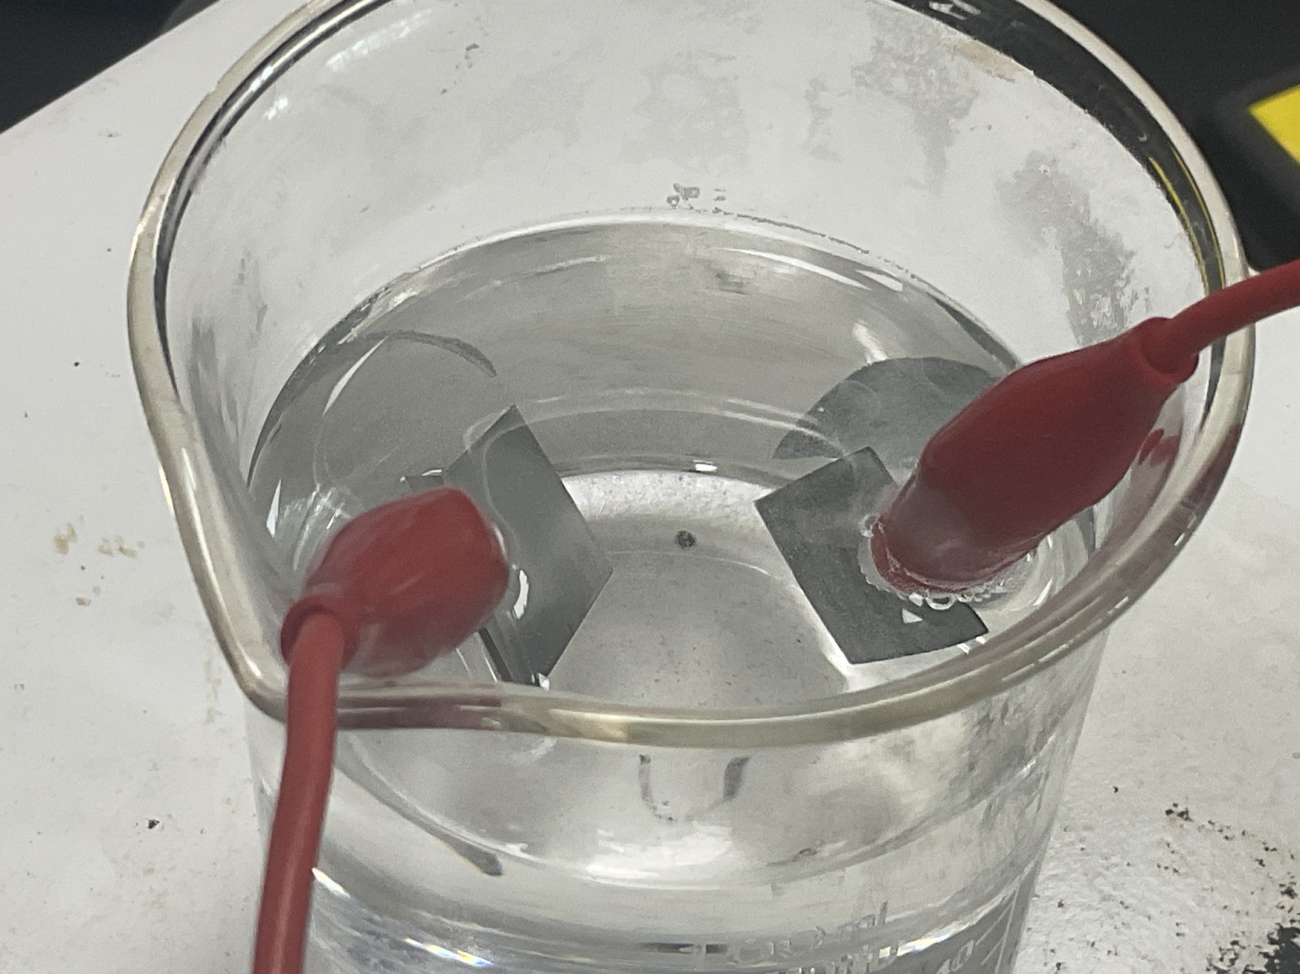

(Fig 1-1) Set the Zn plate on the (-) pole and the Fe plate on the (+) pole

1. Power on the Power Supply and allow it to hydrolyze for 7 minutes. (Fig 1-2)

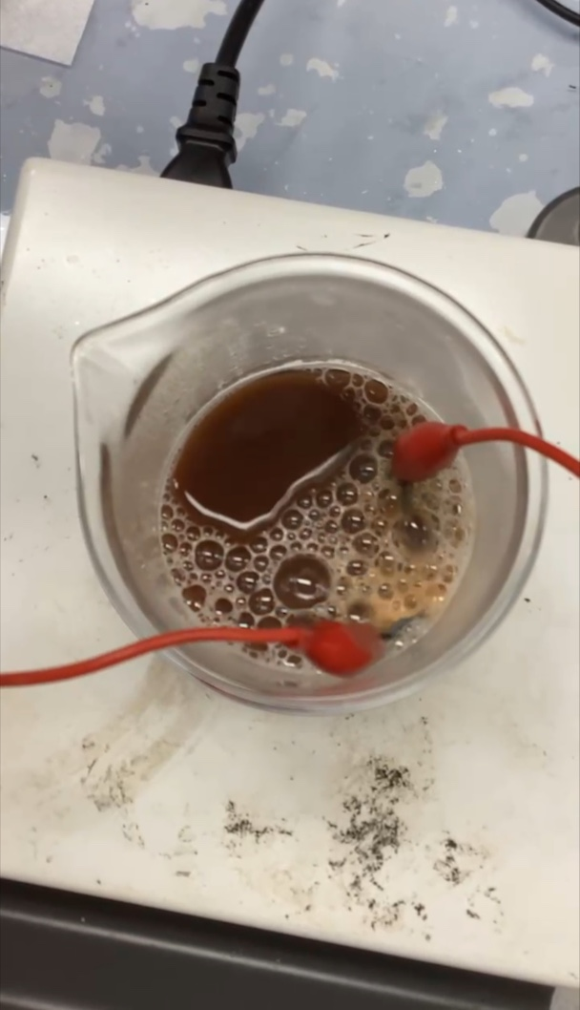

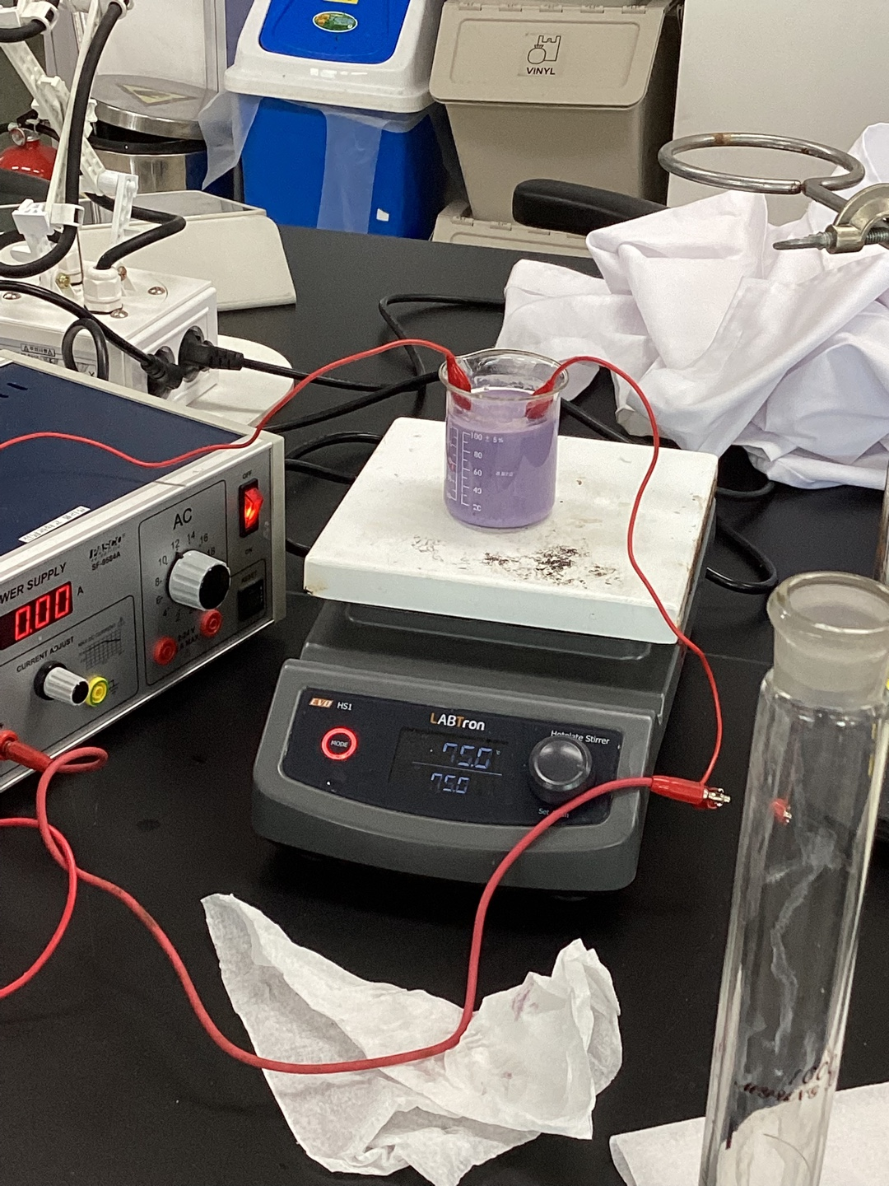

(Fig 1-2) Water electrolysis using Fe2(SO4)3, Cocl2 as a catalyst.

1. After 7 minutes, measure the amount of hydrogen gas produced in each beaker. This can be evaluated relatively by measuring the volume of solution that has decreased after hydroelectrolysis.

Results

|  |  |  |  |
| --- | --- | --- | --- |
| Catalyst | Initial part of the solution | Solution volume after experiment | Reduced solution volume |
| X | 100 | 96.5 | 3.5 |
| NiCl2 | 100 | 96.5 | 3.5 |
| FeSO4 | 100 | 95 | 5 |
| Fe2(SO4)3 | 100 | 85.5 | 14.5 |
| CuCl2 | 100 | 100 | 0 |
| FeCl2 | X | X | X |
| CoCl2 | 100 | 100 | 0 |

[Table 1] This table shows the final remaining and reduced volumes over the course of the experiment.

The extent of hydrogen gas generation using each catalyst was determined by the volume of the reduced electrolyte aqueous solution. NiCl2 produced the same amount of gas as without the catalyst. CuCl and FeSO4 generated more gas than NiCl2, but Fe2(SO4)3 formed the most gas. CuCl2 and CoCl2 were unable to act as catalysts because they were denatured during the process of reaching the required temperature of 75 degrees for the water electrolysis reaction, but rather appeared to act as co-catalysts as no water electrolysis reaction occurred at all. FeCl2 was unable to be tested because it had been stored for a long time and reacted with oxygen and water vapor in the air to form other substances.

Conclusion

I) Reaction rate differences among catalyst metals (Fe, Co, Cu, Ni)

-Reasons for the difference in reaction rate among catalyst metals include electronic structure and redox properties, adsorption energy, and surface structure. The unique electronic structure and redox properties of each metal affect the activation energy of the reaction on the catalyst surface, and certain metals can transfer electrons more efficiently, which can increase the reaction rate. The metal catalyst also determines how the reactants are adsorbed onto the surface. Certain metals can adsorb reactants more strongly or weakly, which affects the rate of the reaction. For example, the better a hydrogen molecule is adsorbed on a catalyst surface, the more effectively it can decompose and the better hydrogen gas is formed. The crystal structure or surface structure of the metal can affect its interaction with the reactants and thus affect the reaction rate.

Ni is relatively inexpensive and has high electrical conductivity, so it was predicted that it would perform well in the hydrogen evolution reaction. However, in the experiments, it did not work as a catalyst, which was predicted to be due to the following reasons

1. the Ni surface may be oxidized or contain impurities. Oxides formed on the surface of Ni catalysts can block the activity of the catalyst and interfere with the hydrogen evolution reaction. Especially in air, Ni can be easily oxidized to form NiO, and this surface oxide seems to have reduced the catalyst efficiency.

2. Ni ions may not have been properly dissolved in alkaline aqueous solutions. This may cause the Ni catalyst to be unevenly distributed and reactions may occur only in certain areas.

Possible solutions to this include pre-activating the surface of the Ni catalyst through a catalyst surface pretreatment process to remove impurities, or storing the catalyst prior to the experiment to prevent it from oxidizing and reducing it if necessary to keep it active.

Similar to Ni, Fe is another widely used catalyst that performs well due to its high electrical conductivity and ability to efficiently transfer electrons during water electrolysis. Fe catalysts in particular have the advantage of being very low cost and abundant compared to other metals, making them suitable for mass production. However, they can have corrosion problems and their stability in long-term water electrolysis needs to be considered.

Co and Cu can react with oxygen to form oxides. This oxidation reaction can be accelerated, especially in high-temperature environments. In addition, copper hydroxide and cobalt hydroxide have lower solubility compared to Fe and Ni hydroxide, resulting in a smaller solubility product, so Cu and Co can precipitate as hydroxides in aqueous NaOH solutions and lose their activity as catalysts. Improvements include controlling the NaOH concentration and pH to minimize hydroxide formation and conducting experiments under inert conditions (Ar, N) to prevent oxidation.

In conclusion, Fe is predicted to be the most suitable catalyst metal for alkaline water electrolysis due to its affordability, high electrical conductivity, catalytic activity, and durability.

II) Reaction rate differences depending on the ions in the catalyst (sulfate, chloride)

Since FeCl2 is not available in the experiment, it is not possible to predict the reaction rate difference based on the experimental results, but the theoretical explanation is as follows.

1. Chloride ions have a single charge and high mobility. The high mobility increases the rate of charge transfer and can have a positive effect on the reaction rate. On the other hand, sulfate ions have a double charge and relatively low mobility. This means that the charge transfer rate is slower than that of chloride ions. 2.

2. Chloride ions can increase catalytic activity due to their high adsorption and reactivity on the catalyst surface. However, sulfate ions have a larger ion size and higher charge density, which can make their adsorption and reaction on the catalyst surface more complicated.

Chloride ions will be more favorable to the reaction than sulfate ions for the following reasons.

III) Reaction rate differences depending on the hydrogen of the catalyst metal (divalent iron, trivalent iron)

Ferrous sulfate and ferrous sulfate have the same composition, only the hydrogen of the iron is different. However, in the water electrolysis reaction Iron(III) sulfate n-hydrate produces about 2.9 times more gas than Iron(II) Sulfate Heptahydrate, which is due to the lattice enthalpy of the two catalysts. The dissociation enthalpy of Iron(III) sulfate n-hydrate is -849.3 kJ/mol, which is larger than the dissociation enthalpy of ferrous sulfate of -69.2 kJ/mol, so the value of energy available for the entire reaction after dissociation will be larger. As the value of energy available is larger, there will be more intermolecular collisions and the reaction rate of water electrolysis will be faster in Iron(III) sulfate n-hydrate. Therefore, the larger the number of catalyst metals, the more favorable the water electrolysis reaction will be.

[Suggestions]

1. The catalysts used in the experiments can be compared with organometallic compounds such as ferrous gluconate as an inorganic salt agent to find a better catalyst. Subsequently, the alkaline water electrolysis process can be developed through the experimental results using organometallic compounds, which are aggregates of organics and metals that have recently attracted attention as catalysts rather than simple metallic catalysts.

1. There are quite a few catalysts that have been compared only in theory, but it is necessary to use them in experiments through pretreatment or redox reactions, or purchase unmodified catalysts to see if the theory and practice tend to be similar.
2. If the intermediates of the catalytic reaction can be identified, the catalytic reaction can be optimized by studying the properties of the material. Therefore, it is necessary to know the exact process of the catalytic reaction..

Discussion

[Production].

During the introduction of AEC (Alkaline Electrolysis Cell), it was found that it is suitable for producing hydrogen in large quantities due to its low initial investment, low power generation cost, simplicity and durability. We thought that if hydrogen is produced relatively cheaply in country A, the transaction price will be relatively low because the unit cost of power generation will be lower than other water electrolysis. This will have a positive impact on the continuous hydrogen value chain between country A and country B. Of course, AEC has the disadvantage that it is susceptible to corrosion and requires a continuous supply of electrolyte to maintain the electrolyte concentration at 35%. However, we believe that the corrosion susceptibility can be solved by using non-precious metal catalysts and the simple structure of AEC, and the electrolyte supply is a problem that can be compensated by further development. On this basis, we propose to use AEC for green hydrogen production.

[Storage]

There are many obstacles to transporting hydrogen from country A to country B. In particular, there is an ocean between the two countries, making it highly impractical to use land-based transportation methods such as railways, trucks, and pipelines.

Several methods have been proposed for transporting hydrogen, but each has its drawbacks. Liquefied hydrogen or hydrogen compression has high social acceptance but requires technological development. Storage methods using methanol, ammonia, and hydrogen carriers can produce carbon dioxide (CO2) and nitrogen oxide (NOx) emissions and are expensive.

Therefore, liquid organic hydrogen carriers (LOHCs) have been considered as a suitable way to transport hydrogen. LOHCs are liquids that reversibly store and release hydrogen through the processes of hydrogenation and dehydrogenation. Hydrogenation is the addition of hydrogen to unsaturated organic compounds to synthesize them into saturated organic compounds, while dehydrogenation is the addition of hydrogen to unsaturated organic compounds to synthesize them into saturated organic compounds.

[Use]

Country B lacks infrastructure and has very few renewable energy sources. If green hydrogen is produced, stored, and transported in country A and used to generate electricity in country B, a value chain can be created that consumes hydrogen while reducing carbon dioxide emissions. There are two ways to use hydrogen: fuel cells and turbines, and the characteristics of each method will greatly affect the infrastructure and value chain in country B. Fuel cells may lead to an increase in small power plants and distributed generation, and additional facilities may be needed to respond to fluctuations in output. On the other hand, large-scale power generation using turbines is expected to be able to use the existing power grid.

2. Investigate the hydrogen technology infrastructure in your country and devise a hydrogen value chain in your country (or with neighboring countries) to achieve net-zero in 2050

Korea's neighboring countries include China, Japan, and North Korea. Since physical exchange with North Korea is not feasible, we thought that China and Japan are the most feasible countries for practical exchange. We thought that we should increase renewable energy generation sources to produce green hydrogen as much as possible. Representative examples of renewable energy include onshore wind, offshore wind, and solar power, and in the case of Korea, which is surrounded by the sea on three sides, if offshore wind farms are built along the west and south coasts, where the water depth is relatively shallow, green hydrogen can be produced using the electricity generated from them. If green hydrogen is obtained from the west coast and south coast, liquefied hydrogen is transported to the metropolitan area through liquefaction and storage, and hydrogen turbines or fuel cell facilities are installed near the metropolitan area, it will help to stabilize the operation of the metropolitan area by supplying the shortage of electricity. As a result, the value chain for achieving Net Zero in 2050 can be organized along the west coast.

* Korea's neighbors include China and Japan. Since it is difficult to have a physical exchange with North Korea, we believe that it is possible to have a practical exchange with China and Japan. We believe that we should increase renewable energy sources to produce green hydrogen. Representative examples of renewable energy include onshore wind, offshore wind, and solar power, and since Korea is bordered by the sea on three sides, if offshore wind farms are built along the west and south coasts, where the water depth is relatively shallow, green hydrogen can be produced using the electricity generated by the wind farms. The green hydrogen produced along the west and south coasts is liquefied and stored at hydrogen liquefaction facilities in those areas, and the liquefied hydrogen is transported to the capital city. Hydrogen turbine or fuel cell facilities near the metropolitan area are expected to supplement the electricity shortage in the metropolitan area to ensure stable operation.

REFERENCES

[1] Chemistry 10th Edition by Steven S. Zumdahl

[2] Principles of Modern Chemistry 7th Edition by David W. Oxtoby, H. Pat Gillis, Alan Campion